SCHOOL OF COMPUTER SCIENCE AND ARTIFICIAL INTELLIGENCE |  |  |  |  | DEPARTMENT OF COMPUTER SCIENCE ENGINEERING
Program Name: B. Tech |  |  |  | Assignment Type: Lab |  |  | Academic Year:2025-2026
Course Coordinator Name |  |  |  | Venkataramana Veeramsetty
Instructor(s) Name
  Dr. V. Venkataramana (Co-ordinator)
  Dr. T. Sampath Kumar
  Dr. Pramoda Patro
  Dr. Brij Kishor Tiwari
  Dr.J.Ravichander
  Dr. Mohammand Ali Shaik
  Dr. Anirodh Kumar
  Mr. S.Naresh Kumar
  Dr. RAJESH VELPULA
  Mr. Kundhan Kumar
  Ms. Ch.Rajitha
  Mr. M Prakash
  Mr. B.Raju
  Intern 1 (Dharma teja)
  Intern 2 (Sai Prasad)
  Intern 3 (Sowmya)
  NS_2 ( Mounika)
Course Code |  |  | 24CS002PC215 | Course Title |  | AI Assisted Coding
Year/Sem |  |  | II/I | Regulation |  | R24
Date and Day  of Assignment |  |  | Week5 - Monday | Time(s)
Duration |  |  | 2 Hours | Applicable to  Batches
AssignmentNumber: 9.1(Present assignment number)/24(Total number of assignments)
 | Q.No. | Question |  |  |  |  |  | Expected Time  to complete
 | 1 | Lab 9 – Code Review and Quality: Using AI to improve code quality and readability  Lab Objectives  - Inline comments  - Docstrings  - Auto-documentation tools  - AI-assisted summarization  Task Description #1 (AI-Assisted Bug Detection)  Scenario: A junior developer wrote the following Python function to calculate factorials:  def factorial(n):  result = 1  for i in range(1, n):  result = result * i  return result  - Run the code and test it with factorial(5)  (expected output = 120).  - Use AI (prompting) to review this code and identify the bug.  - Ask AI to suggest corrections and rewrite the code.  - Compare AI’s corrected code with your own fix.  Manual Corrected Code:  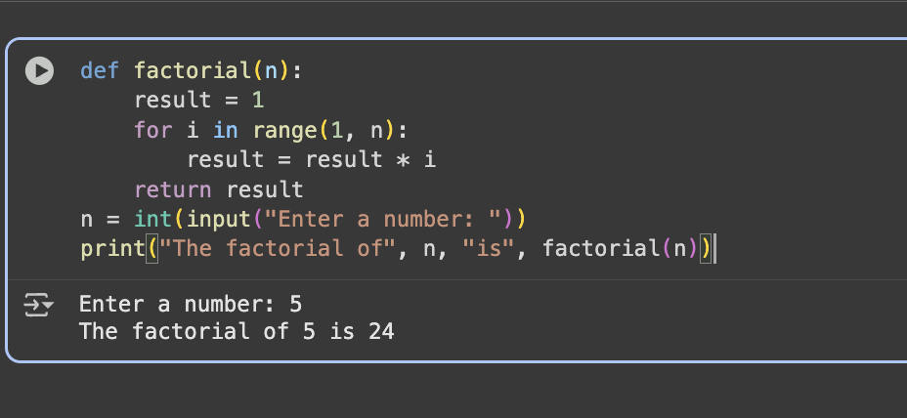  AI’s corrected code:  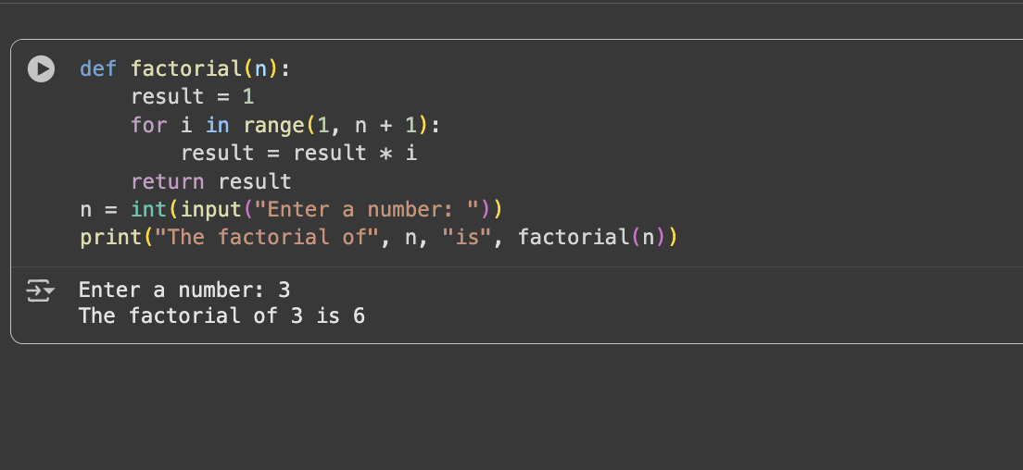  Comparison:  As we can see from the above two pictures, the manual and ai corrected codes are identical for the one exception being that the AI increased the loop to n number of values.  Task Description #2 (Improving Readability & Documentation)  Scenario: The following code works but is poorly written:  def calc(a,b,c):  if c=="add":  return a+b  elif c=="sub":  return a-b  elif c=="mul":  return a*b  elif c=="div":  return a/b  - Use AI to review this code for readability, naming, and documentation issues.  - Prompt AI to rewrite the code with:  - Clear function & variable names.  - Proper docstrings.  - Exception handling for division by zero.  - Compare the before-and-after versions to evaluate AI’s contribution.  Prompt  Correct the given code usinf functions, docstrings and proper handling for division by zero  CODE:  before:  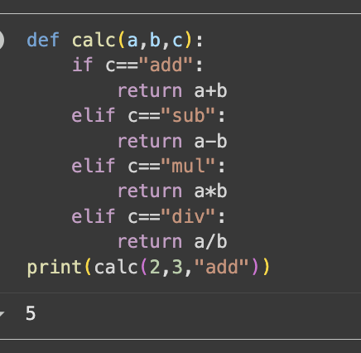  After:  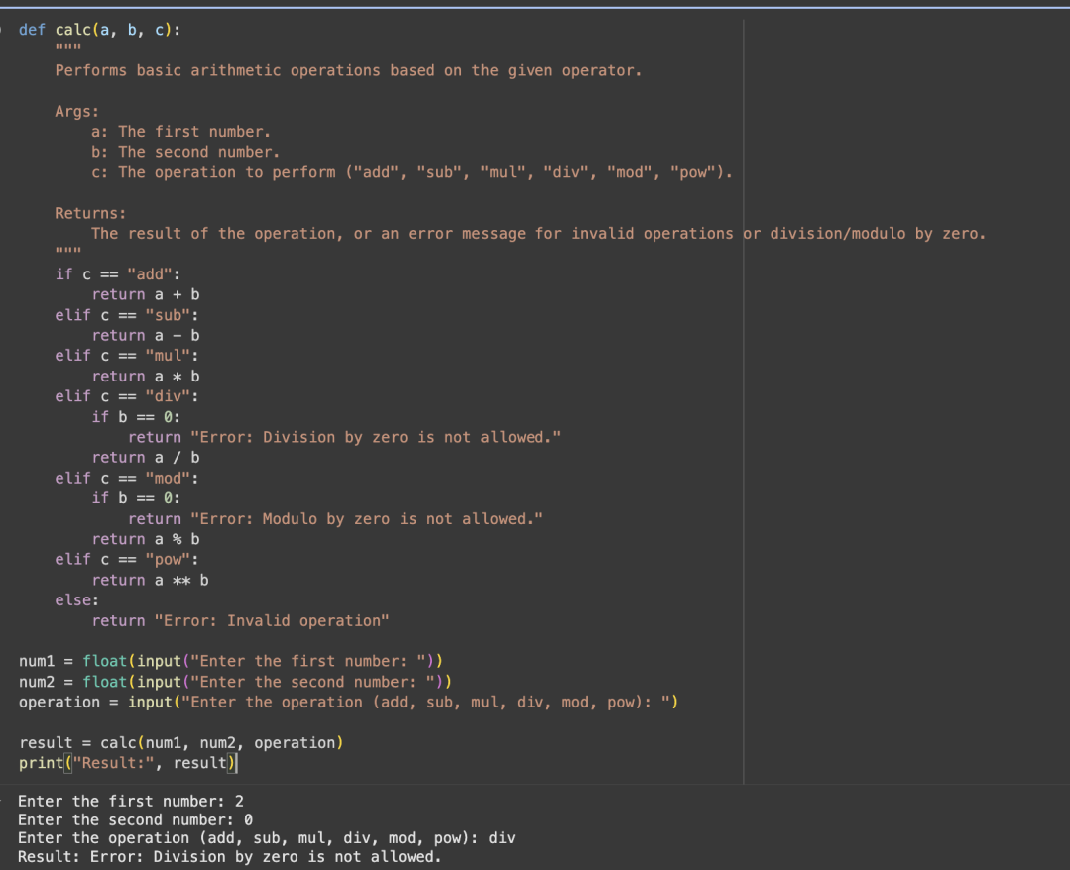  Comparison:  Naming:  - Before: calc(a,b,c)  - After: clac(a,b,c)  Documentation  - Before: No docstring.  - After: explicit docstring usage and explanation  Error Handling  - Before: No check for division by zero.  - After: checks for zero and let’s the user know that division by zero is not allowed  Task Description #3 (Enforcing Coding Standards)  Scenario: A team project requires following PEP8 style guide. One developer submits:  def Checkprime(n):  for i in range(2,n):  if n%i==0:  return False  return True  - Run this code and verify correctness.  - Use AI to perform a code quality review for PEP8 compliance.  - Prompt AI to return a refactored version with proper indentation, spacing, and naming conventions.  - Discuss how automated AI review can save time in large-scale projects.  Prompt  Refractor the following code using proper indentation, spacing and naming conventions  Verification of code  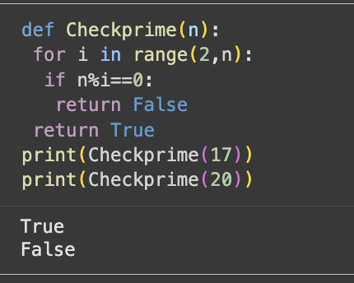  AI refractored version:  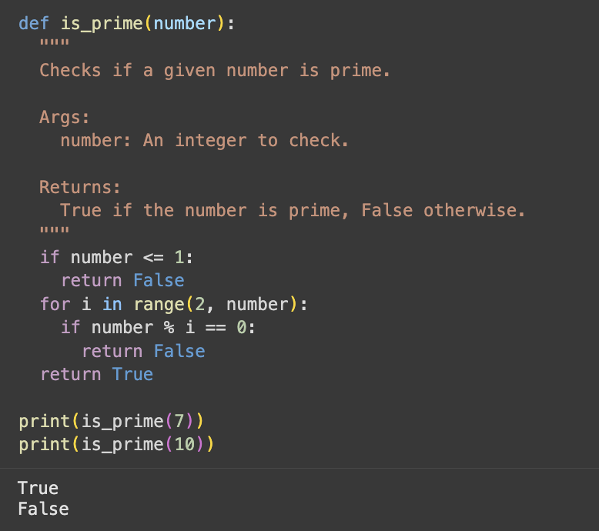  Review of code:  Function naming: Checkprime should be is_prime(number)  Indentation: Missing 4-space indentation inside the function.  Spacing: Needs spaces around operators (%, ==, <=).  Docstring: Missing explanation of parameters, return value, and purpose.  Edge case handling: number <= 1 should return False.  Task Description #4 (AI as a Code Reviewer in Real Projects)  Scenario: You are part of a GitHub project. A teammate submits this pull request:  def processData(d):  return [x*2 for x in d if x%2==0]  - Review this function manually for readability, reusability, and edge cases.  - Use AI to generate a code review comment, focusing on:  - Naming conventions.  - Input validation (e.g., what if d is not a list?).  - Adding type hints.  - Modify the function based on AI’s suggestions.  - Write a short reflection: Would you trust AI as a standalone reviewer, or only as a support tool? Why?  Modifying the function  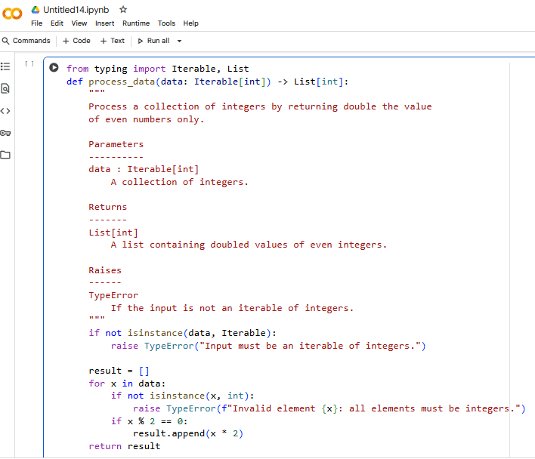  Code Review:  Naming conventions: Please use snake_case (process_data) to follow PEP8.  Input validation: Consider adding checks to ensure d is an iterable of numbers, otherwise raise a helpful error.  Type hints: Adding type hints (e.g., List[int] -> List[int]) improves clarity.  Documentation: A short docstring would make the function easier to understand for future contributors."  Reflection  No, not fully.  - AI is excellent at catching style issues, naming, documentation, and common pitfalls.  - But AI might miss business logic errors, performance concerns, or project-specific requirements.  - Human reviewers bring domain knowledge and context that AI doesn’t always have |  |  |  |  |  | Week5 - Monday

